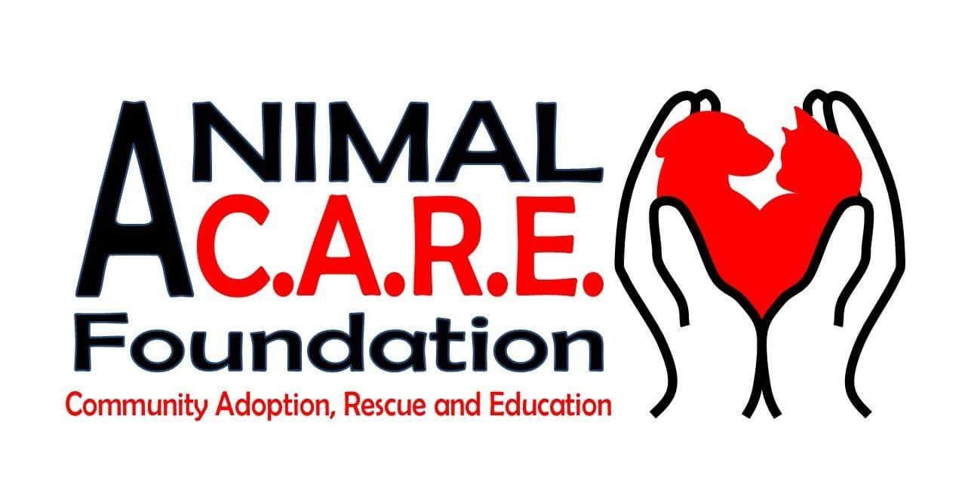
VOLUNTEER APPLICATION

Name:___________________________ Address:______________________________

City:___________________ State:___________ Zip Code:________________

Date of Birth:_________________ Age:________

Email:___________________________________________

Home Phone:________________________ Cell Phone:______________________

Employment:__________________________________

Are you presently attending School? Yes No
Name of School:________________________________________

EMERGENCY CONTACT INFORMATION:

Name:______________________________ Relationship:___________________

Home Phone:________________________Cell Phone:_____________________

Do you have any allergies or special needs we should know about?

______________________________________________________________________

AREAS TO VOLUNTEER:

Please let us know what areas you are interested in volunteering:

_____Fostering dogs/cats in your home
_____Adoption Fairs
_____Transport animals to other rescues
_____Fundraising
_____Event Planning
_____Grant Writing
_____Education/Visiting Schools and Youth Groups
Animal C.A.R.E. Foundation (ACF)
P.O. Box 105
Welcome, NC 27374

WAIVER

As a volunteer I shall represent the Animal C.A.R.E. Foundation (ACF) and will conduct myself in a respectful manner. I shall treat all animals that are in my care with the utmost respect and will never handle them in a rough unkind manner. If I can no longer volunteer, I shall agree to return all property within 1 week of resignation (animals, crates, kennels, traps). I, the undersigned, assume the risk of being bitten, scratched, or injured in connection with my ACF volunteer work. ACF is not liable to me or my guardian for any injuries, damages, liabilities, losses, judgments, costs or expenses whatsoever, which I might suffer or sustain in connection with my ACF volunteer activities, I will indemnify, defend and hold the ACF harmless from and against my claims, lawsuits, injuries, damages, losses, costs or expenses whatsoever, sustained by any animal or person in connection with my intentional misconduct or grossly negligent performance of my volunteer activities. It is further agreed and understood that I shall maintain in full force and effect, a policy of insurance covering medical treatment and all related costs in the event of an injury to myself as a result of participation in any and all activities at the ACF as aforesaid. I also agree that if I do not maintain in full force in and effect a policy of insurance, I am still liable for medical treatment and all related costs in the event of an injury to myself or any aforementioned minor/s as a result of participation in any and all activities involving the Animal C.A.R.E. Foundation as aforesaid.

I agree that I have read and agree to the foregoing.

Printed Name_________________________________________________

Signature_______________________________________Date__________

Parent/Guardian Signature (if under 18)

__________________________________________ Date_________

- WAIVER OF LIABILITY AND INDEMNIFICATION

The work performed by the Volunteer shall be at the risk of the Volunteer exclusively. Volunteer agrees to perform work in compliance all applicable State, Federal, and Local statutes, codes, and ordinances. Volunteer assumes any and all risks, including unknown risks, which are or may be associated with the work performed by Volunteer, including the ordinary negligence of Animal CARE or other Volunteers.

Volunteer recognizes that there are certain inherent risks in performing the services for which Volunteer has offered to undertake, and Volunteer hereby assumes full responsibility for personal injury, death, and/or property damage to Volunteer and/or Volunteer’s employees and/or associates arising out of, or in any way connected with the work performed, materials furnished, or services provided to Animal CARE.

Volunteer agrees to indemnify and defend Animal CARE against all claims, causes of action, damages, judgments, costs or expenses, including reasonable attorney’s fees and other litigation costs, which may in any way arise from, or in any way connected to, the work performed, materials furnished, or services provided by Volunteer, his employees or subsidiaries, to Animal CARE

- JURISDICTION AND VENUE

This Agreement is governed by the laws of the State of North Carolina. Any controversy or claim arising out of or relating to this Agreement, or the breech thereof, shall be heard in Davidson County, North Carolina.

- Binding effect.

This Agreement shall be binding upon and inure to the benefit of the respective parties, and their successors and assigns, heirs and personal representatives, except as otherwise expressly provided herein.

PARTIAL INVALIDITY: If any provision of this Agreement is later deemed invalid or unenforceable, then all other provisions of the Agreement shall continue in full force and effect.

AMENDMENTS MUST BE IN WRITING:

Any amendment, waiver, or changes to the terms and conditions of this Volunteer Agreement must be in writing, signed by both Volunteer, and at least two sitting members of the Board of Directors of Animal CARE Foundation in order to be valid.

ATTORNEY’S FEES

If either party named herein brings legal action or arbitration to enforce the terms of this Agreement or to declare rights hereunder, the prevailing party in any such action, trial, arbitration or appeal, shall be entitled to reasonable attorney’s fees to be paid by the losing party as fixed by the court or arbitrator.

12/30/2019

